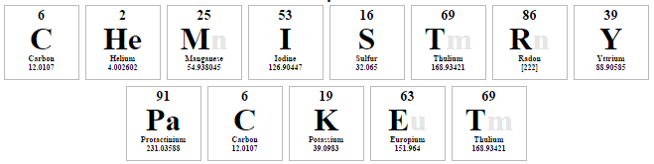

Names:_________________________Date:______
Objective: Students will develop a model that illustrates the arrangement of electrons using the Bohr Model.
Bohr Models
- Used to show arrangement of electrons.
- Electrons are placed on the ____________ shell first. Once full, extra electrons are placed in the next shells.
- Maximum number of electrons on shells:
  - 1st = ______ electrons
  - 2nd – ______ electrons
  - 3rd – ______ electrons
    - After element 18 the shells fill differently
- Periodic Table Tips
  - The periodic table can help you quickly complete the Bohr model
    - The number of periods shows you the number of _______________
    - The number of groups shows you the number of ________________ in the outer shell
- Bohr Model Practice. Fill in the blanks below for Phosphorus and draw the Bohr model.

Symbol: _________ Atomic Number: _________
Atomic Mass: _________ Protons: _________
Neutrons: _________ Electrons: _________

Bohr Model Worksheet
Use the description sheet and the periodic table to help you complete the following Bohr models.

Element | Atomic # | Atomic Mass | Protons | Neutrons | Electrons | Bohr Model
Carbon | 6 | 12 | 6 | 6 | 6
Hydrogen | 1 | 1
Lithium | 3 |  | 3 |  | 3
Magnesium | 12 | 24
Boron | 5 | 11

