METRICS AND MEASUREMENT TEST REVIEW
Indicate how many significant figures there are in each of the following measured values then put in scientific notation.
- 246.32  - 107.854  - 100.3  - 0.678  - 1.008  - 0.00340 |  | - 0.0001  - 700000  - 350.670  - 1.0000  - 32000  - 14.600

13) 3 x 102 = _________________ 14) 6 x 10-3 = ________________
15) 7 x 104 = _________________ 16) 900 x 10-2 = ______________
17) 2.4 x 103 = _______________ 18) 4 x 10-6 = _________________

19.) Describe each target using the words accurate and precision in each statement.
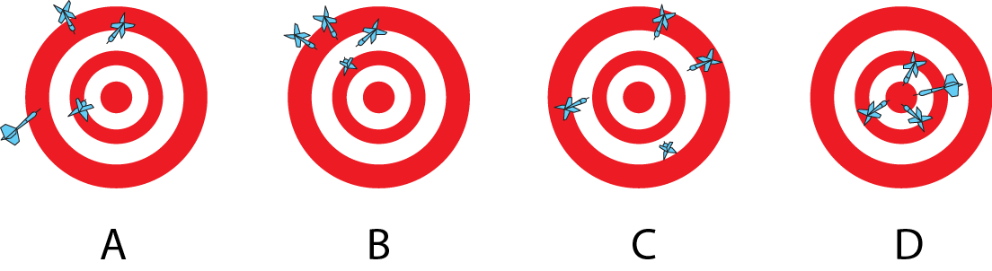

Convert the following measurements:
20.) 2000 mg = _______ g  23) 104 km = _______ m | 21) 2500 m = _______ km  24) 480 cm = _____ m | 22) 50 cm = _____ m  25) 6.3 cm = _____ mm

Compare using <,> or =.
26) 63 cm___ 6 m  27) 5 g ____508 mg  28) 1,500____ mL 1.5 L | 29) 536 cm ____53.6 hm  30) 43 mg____ 5 g  31) 3.6 m_____ 36 cm

32. Write down 3 of the most important lab safety rules to follow in the lab.

METRICS AND MEASUREMENT TEST REVIEW
Indicate how many significant figures there are in each of the following measured values then put in scientific notation.
- 246.32  - 107.854  - 100.3  - 0.678  - 1.008  - 0.00340 |  | - 0.0001  - 700000  - 350.670  - 1.0000  - 32000  - 14.600

13) 3 x 102 = _________________ 14) 6 x 10-3 = ________________
15) 7 x 104 = _________________ 16) 900 x 10-2 = ______________
17) 2.4 x 103 = _______________ 18) 4 x 10-6 = _________________

19.) Describe each target using the words accurate and precision in each statement.

Convert the following measurements:
20.) 2000 mg = _______ g  23) 104 km = _______ m | 21) 2500 m = _______ km  24) 480 cm = _____ m | 22) 50 cm = _____ m  25) 6.3 cm = _____ mm

Compare using <,> or =.
26) 63 cm___ 6 m  27) 5 g ____508 mg  28) 1,500____ mL 1.5 L | 29) 536 cm ____53.6 hm  30) 43 mg____ 5 g  31) 3.6 m_____ 36 cm

32. Write down 3 of the most important lab safety rules to follow in the lab.

